Chapter 16, Solution 20.

Find i(t) for t > 0 in the circuit of Fig. 8.43.

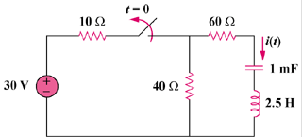
20V

Figure 16.43
For Prob. 16.20.
8.16

Step 1. Convert the circuit into the s-domain and write one loop equation noting that i(0) = 0 and v_{c}(0) = 16 volts.

60 Ω

40 Ω

2.5s

10³/s

16/s

+
−

I

[(1000/s)]I +[16/s] + [2.5s]I + [40+60]I = 0 or
[(2.5s²+100s+1000)/s]I = –16/s or I = –16/[2.5(s²+40s+400)] = –.64/(s+20)²

Step 2. I = [A/(s+20)] + [B/(s+20)²] where B = –64 so A = 0. Thus,

i(t) = 6.4te^{–20t}u(t) A.

